Terraform Task

Step1:

First we need enter into the AWS configure and create the folder also

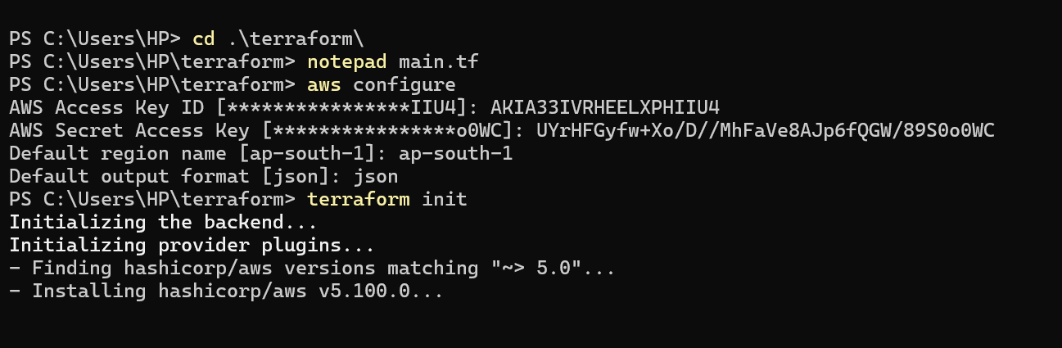

And the main.tf file is mentioned

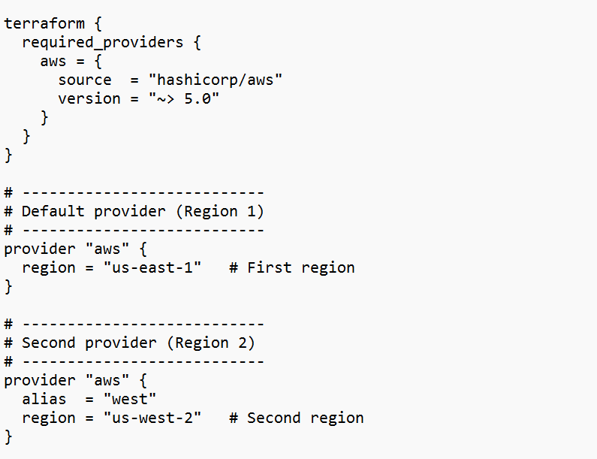

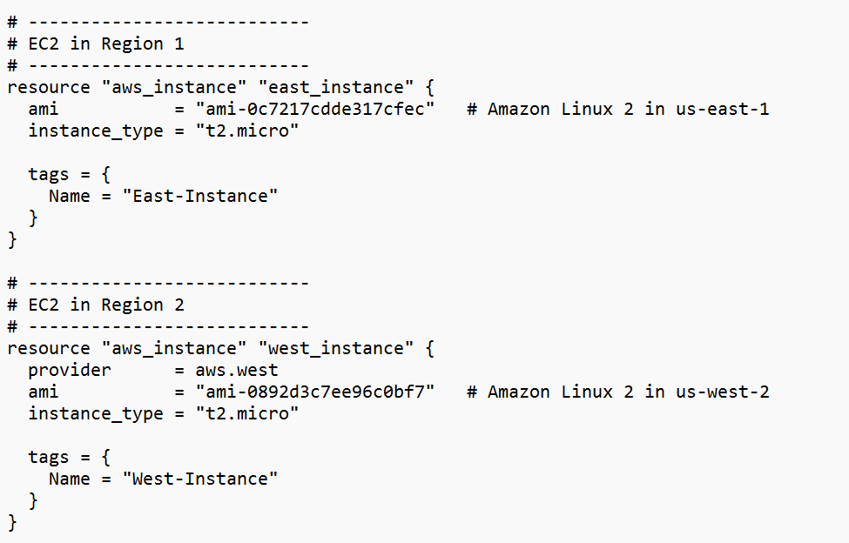

And Ececute the command terraform init

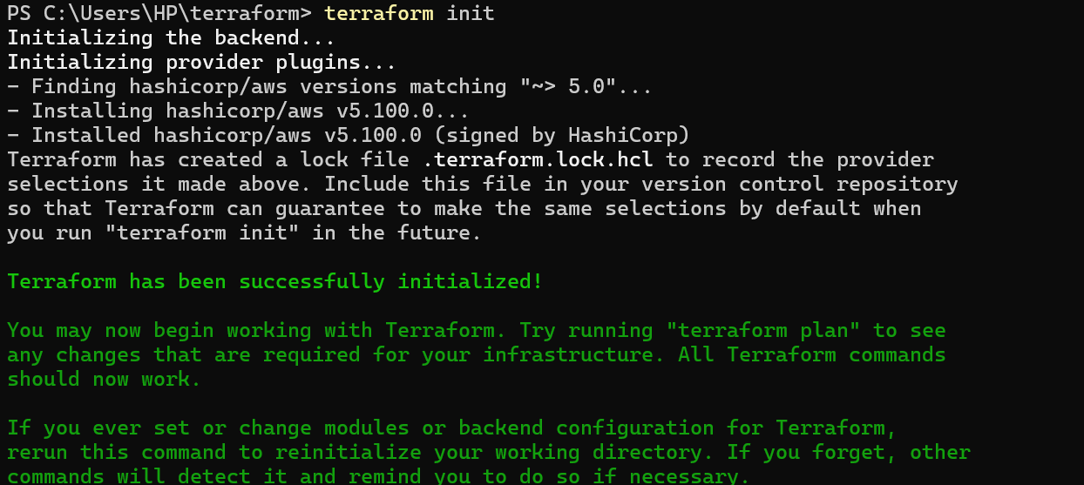

And terraform plan command

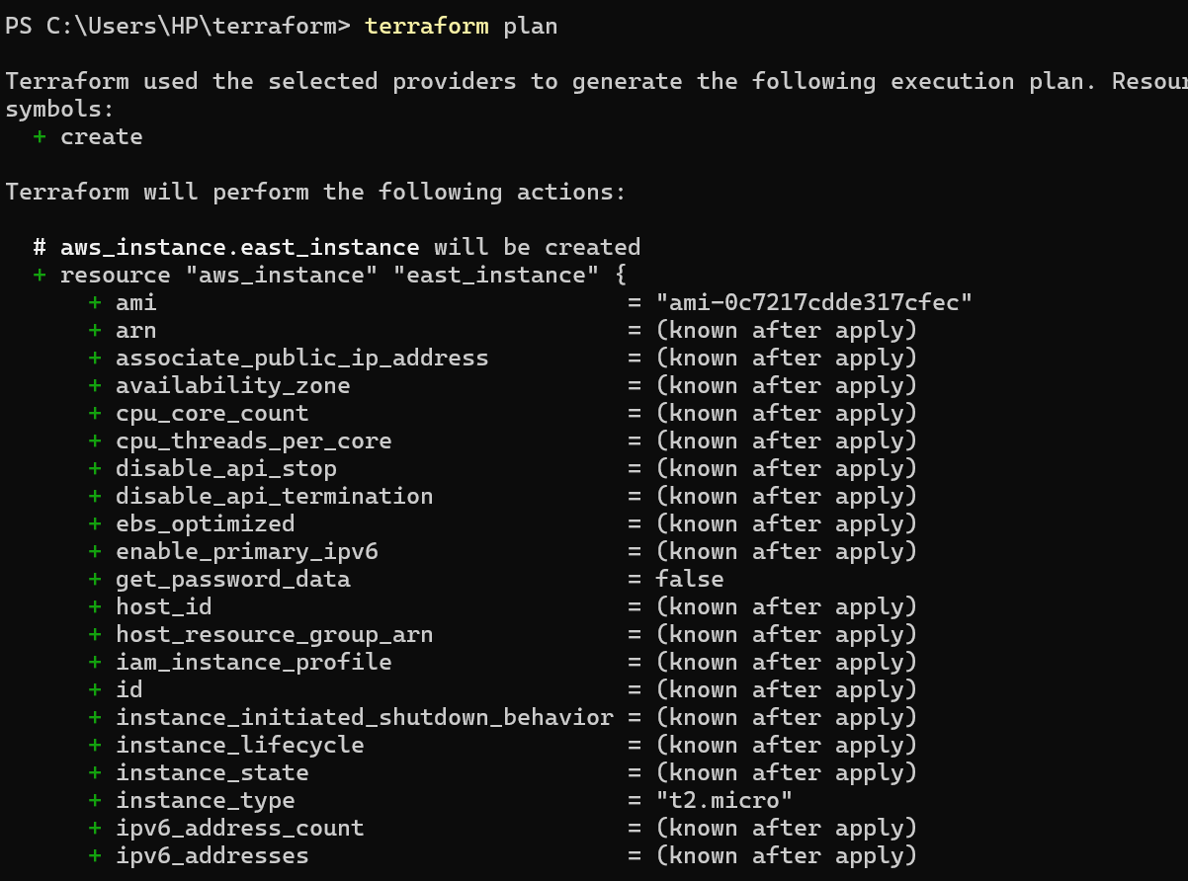

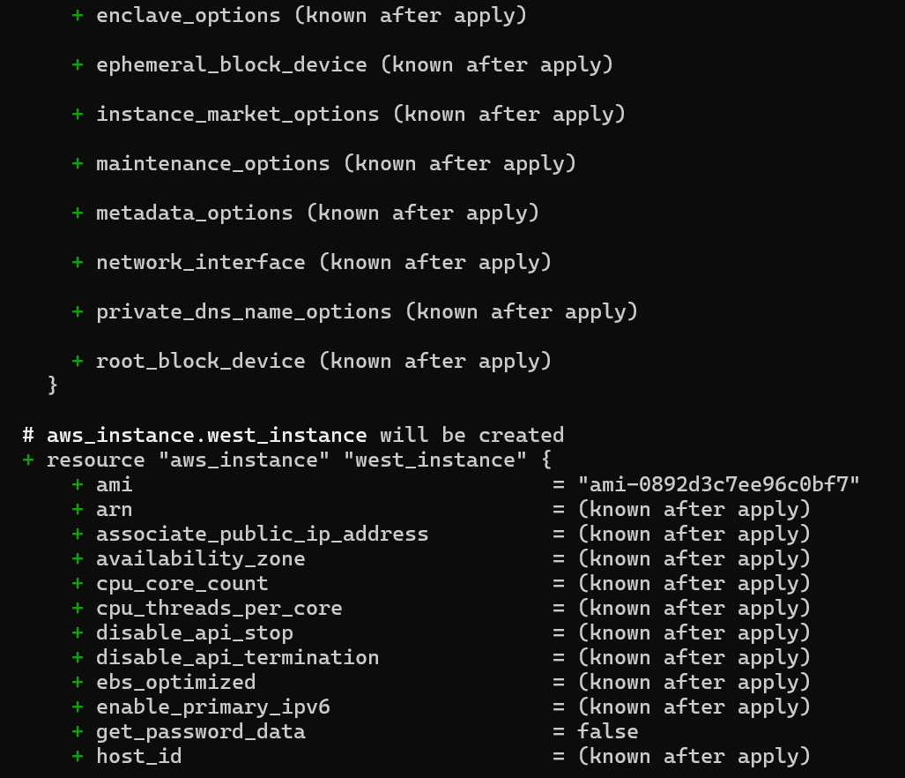

And terraform apply command

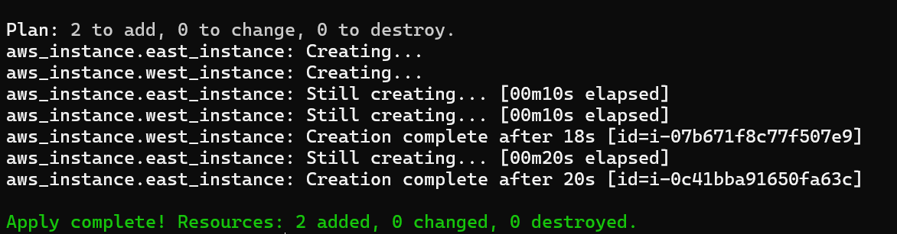

And confirming the instance is created in aws cloud

